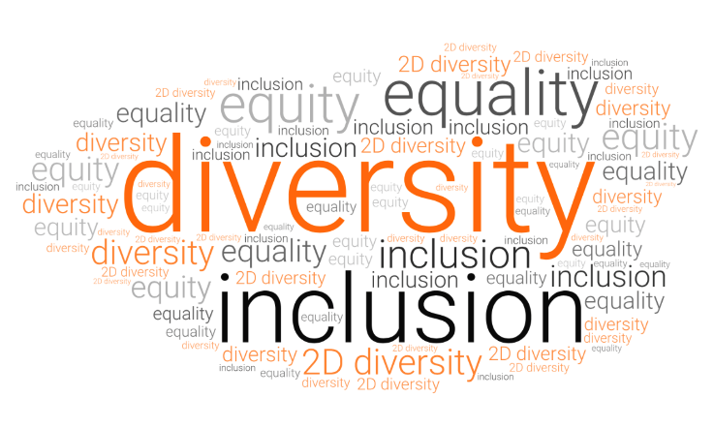

***DIVERSITY AND INCLUSION***

***GUIDELINES***



***(INSERT COMPANY NAME)***

**TABLE OF CONTENTS**

1. WHY FOCUS ON DIVERSITY AND INCLUSION IN THE WORKPLACE? 3

**a.** **Benefits to the organisation** 3

**b.** **Benefits to the employee** 3

2. STRATEGIES TO IMPROVE DIVERSITY AND INCLUSION IN THE WORKPLACE 3

**a.** **General** 3

**b.** **Uniforms** 4

**c.** **Facilities** 4

**d.** **Mentoring** 4

**e.** **Employment Status** 5

**f.** **Recruitment and Interviewing:** 5

**g.** **Wages and Salaries** 5

**h.** **Training and Development:** 6

**i.** **Marketing Material:** 6

**j.** **Employee Assistance Provider:** 6

**k.** **Gender Reporting:** 6

3. POLICIES AND DOCUMENTATION 7

4. ADDITIONAL RESOURCES 7

# **WHY FOCUS ON DIVERSITY AND INCLUSION IN THE WORKPLACE?**

## **Benefits to the organisation**

* Increased talent attraction and retention.
* Lower absenteeism and turnover.
* Positive reputation stemming from best practice approach.
* Increase input and perspective from broadened employee perspective.
* Increase staff morale and motivation.
* Maximizing skills and experiences of employees which may have gone untapped.

## **Benefits to the employee**

* Improved opportunities (such as upskilling and career advancement) in traditionally under-represented groups.
* Increase trust of employees to be their authentic self at work.
* Greater connection and morale at work.
* Increased job satisfaction.
* Pride in contributing to a positive work environment.
* Decrease stress and anxiety of employees.
* Environment that fosters respect and appreciation of others
* Increase trust in employer.

# **STRATEGIES TO IMPROVE DIVERSITY AND INCLUSION IN THE WORKPLACE**

## **General**

* Appoint diversity and inclusion representatives.
* Ensure employees from all genders are appointed to committees.
* Ensure employee engagement and culture surveys include questions on inclusion, barriers to success, appropriate workplace behaviours and allow for employees to make suggestions for improvement.
* A purple background with a face and text

  AI-generated content may be incorrect.Add key dates to the Company calendar and celebrate accordingly (i.e. NAIDOC week, Pride week, International Women’s Day etc.)



* Ensure leadership / management positions are adequately represented across all genders.
* Add key activities that celebrate inclusion such as a shared lunch that encourages international dishes brought to work highlighting different cultural backgrounds.
* Consider broader representation when bringing in key speakers and when selecting employee representatives to attend events.

## **Uniforms**

Ensure gender appropriate uniforms considering differences in individuals shape and sizes.

## **Facilities**

Gender appropriate facilities (bathroom and changerooms) across working locations. Where employees work on subcontractor sites, ensure facilities are available for people of all genders including men and woman.

## **Mentoring**

Where a female is employed in a male dominated industry or position, assign a suitable mentor to the employees. A female will likely assist the employee is assimilate into the workplace quicker and will encourage open communication about any barriers to success which may occur. This may include an external person from an industry body or via the Geelong Manufacturing Council.

## **Employment Status**

Where a vacancy occurs, consider reframing the position to be available on a job share basis. Offer part-time positions with school-friendly hours and flexible working arrangements.

## **Recruitment and Interviewing:**

Undertake an audit of job descriptions and job advertisements to ensure the content does not inadvertently disadvantage people based on gender, age, ethnicity, disability, nationality, identity.

Implement a broader recruitment strategy to attract candidates from non-traditional backgrounds with limited experience and offer to train successful candidates.

Create job advertisements which are appealing to females by including images which show diversity.

Promoting from within the Company where possible by supporting employees drive to progress.

Ensure interview questions are fair and equitable and relate to the inherent requirements of the position on offer and do not ask unrelated questions which may be discriminatory. This includes questions about people’s age, children and carer responsibilities.

Ensure the Company Statement reinforces the stance on diversity and equal opportunity in advertising templates. For example:

*“Our Company supports equal opportunity in employment, encourages people from all backgrounds and values individual perspectives and experiences.”*

## **Wages and Salaries**

Ensure wages and salaries are fair and equitable, considering the position and the incumbents’ skills and experience, regardless of and employee’s gender. This approach leads to employee satisfaction, retention tells employees everyone is equal.

## **Training and Development:**

Provide mentoring opportunities and leadership opportunities for under-represented employee groups.

Offer apprenticeships to existing employees whose gender is not the norm in a particular position such as a Fitter or Electrician.

Ensure training opportunities are open to all employees and that the nature of opportunity supports employees’ personal circumstances where possible.

Roll out training in Workplace Behavioural Expectations to ensure all employees and management are aware of their own and the Company’s responsibilities and obligations relating to workplace behavior and the prevention of discrimination, harassment, sexual harassment and bullying.

Roll out training for individuals who participate in interviewing to ensure this cohort is fully aware of obligations and recruitment and retention strategies.

## **Marketing Material:**

Ensure marketing material reflects the Company’s commitment to creating a diverse and inclusive culture. Be this in job advertisements, Company messaging, in the onboarding process, on the Company website.

## **Employee Assistance Provider:**

Engage with an Employee Assistance Provider (EAP) for use be all employees.

## **Gender Reporting:**

Undertake gender equality reporting regardless of the size of the business and formal requirement to do so. An employer may also set their own targets in relation to the ratio of different genders including males and females working at the Company.

# **POLICIES AND DOCUMENTATION**

Establish policies and procedures and documentation which support diversity, inclusivity and equal opportunity.

* Flexible Working Arrangements Policy
* Recruitment Policy and Procedure
* Training and Development Policy
* Remuneration Policy
* Parental Leave Policy
* Workplace Behaviour Policy
* Family and Domestic Violence Leave Policy
* Induction Checklist
* Job Advertisements
* Interview Questionnaires

# **ADDITIONAL RESOURCES**

**Geelong Manufacturing Council -** <https://www.geelongmanufacturingcouncil.com.au/>

**Diversity Council Australia -** <https://www.dca.org.au/resources>

**Human Rights Commission**

<https://humanrights.gov.au/our-work/employers/toolkits-guidelines-and-other-resources>

**Diversity Australia -** <https://www.diversityaustralia.com.au/about-us/resources/>

**Thrive At Work**

<https://www.thriveatwork.org.au/resources/diversity-and-inclusion/>

**Workplace Gender Equity Agency -** <https://www.wgea.gov.au/resources>

